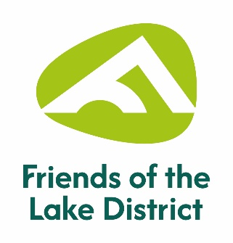
Friends of the Lake District
Dry Stone Walling Competition
Saturday 30th May 2026

*If you have a trophy from the last competition in 2025, could you please return it polished and engraved to the office or bring it with you on the day.

Name: ___________________________________________________________________________

Address: _________________________________________________________________________

__________________________________________________Post Code: _____________________

Telephone: ______________________________________________________________________

Email: ___________________________________________________________________________

Competition Class: ________________________________________________________________

NB. If you are taking part in the DSWA Ellwood Grand Prix, please tick here: Yes ☐

Dietary requirements: (lunch will be provided for those who book in advance)
________________________________________________________________________________

Any medical information we need to be aware of for your safety on the day and an emergency contact name and number:

________________________________________________________________________________

________________________________________________________________________________

I have read the rules of the competition and I agree to be bound by them.

Signature: ____________________________________________ Date: ______________________

Please complete and send this form to:

Kelley Sproston-Heath,
Friends of the Lake District, Murley Moss, Oxenholme Road, Kendal, LA9 7SS
Tel: 01539 720788 or Email: kelley.sproston-heath@fld.org.uk

If you would like to change the way we communicate with you, please call 01539 720788 or email info@fld.org.uk Friends of the Lake District is committed to ensuring your privacy is protected and that data collected will only be used in accordance with our Privacy Policy, which can be found at www.friendsofthelakedistrict.org.uk/privacy-policy

